**Task 2:**

**Problem Statement:**

Writing a logic in main.tf and variables.tf files for creating multiple networks resources to perform looping of resource entities (with count) and applying it upon Azure resource creation using Terraform.

**main.tf**

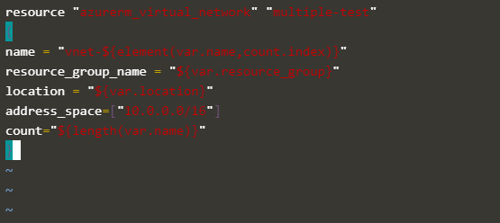

**variables.tf**

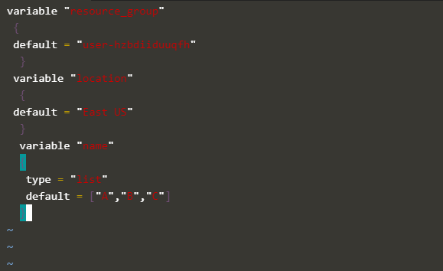

To arrange the format, run the **terraform fmt** command.

Run the **terraform init** command to initialize the terraform environment.

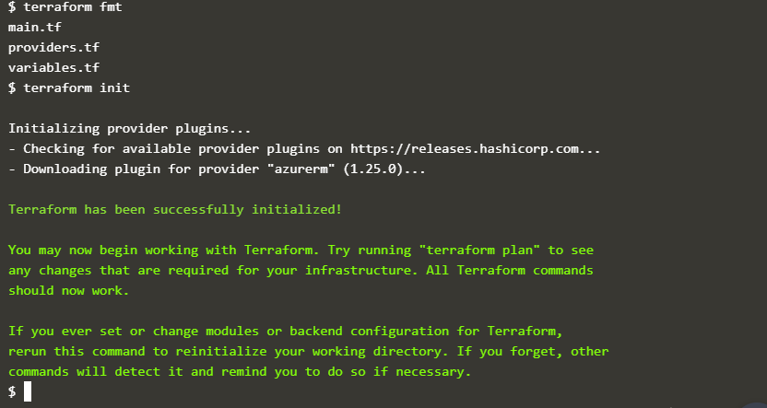

Run the **terraform plan** commands to create the virtual network infrastructure

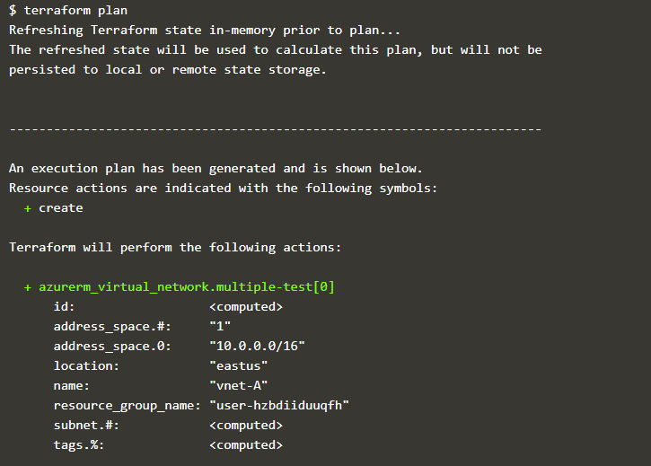

#### C:\Users\HP\Pictures\Screenshots\Screenshot (310).png

Run the **terraform apply** commands to apply changes to create the virtual network infrastructure.

#### C:\Users\HP\Pictures\Screenshots\Screenshot (311).png

#### C:\Users\HP\Pictures\Screenshots\Screenshot (312).png

#### Enter “yes” to apply the changes

#### C:\Users\HP\Pictures\Screenshots\Screenshot (313).png

#### C:\Users\HP\Pictures\Screenshots\Screenshot (314).png

#### Destroying Virtual Network

#### Run terraform destroy command it will destroy all the network resources

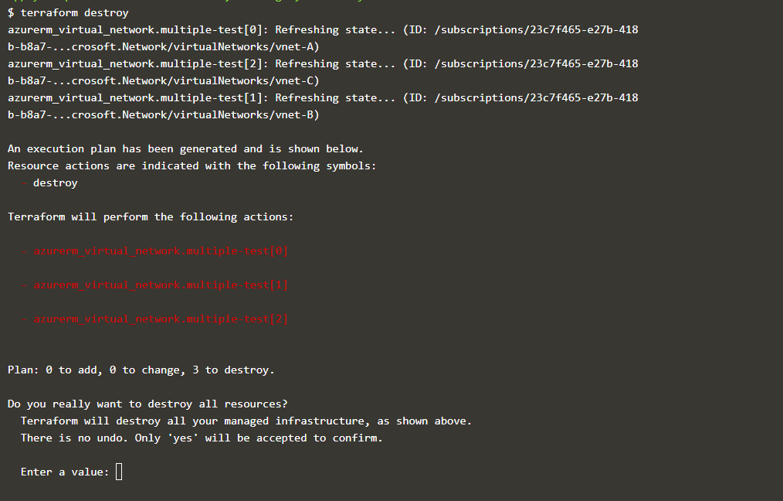

#### Enter “yes” to apply the changes to destroy

